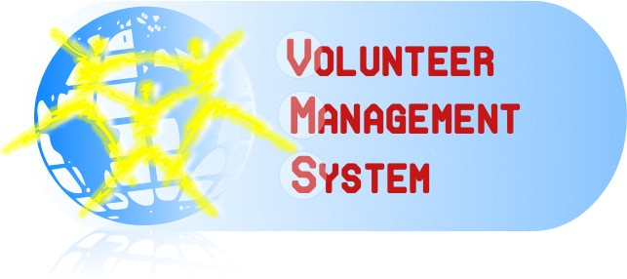

Fınal Report
Industrial Challenge Project

APOLLO TEAM
Content
1 Introduction 3
1.1 Purpose 3
1.2 Definitions 3
2 Overview 3
2.1 Problem Description 3
2.2 Solution: Volunteer Management System (VMS) 4
3 Features 5
4 Functional Requirements 6
5 Non-Functional Requirements 7
6 System Architecture 8
7 Summary 9

Introduction

Purpose
This document is prepared to explain main characteristics of Volunteer Management System.
After an introduction with problem description and our overview of our proposed solution; VMS, we continue by explaining features and requirements. In order to avoid any confusion by detailed explanations, only key requirements are included and others are only listed with their references to related project artifacts. At the end of the document, the candidate architecture that can achieve the desired requirements is given.

Definitions
Volunteer: Any person who uses VMS client /Mobile Application to help in crisis situations.
Crisis: Disasters that interrupts normal life
Incident: Unexpected and non-routine event that can cause trouble to the human beings normal day to day life, in VMS these incidents will be registered under a crisis
Crisis management portal: One of the main interfaces which crisis manager uses to manage a crisis.
Mobile application: Software application, which volunteers use to interact with the VMS, also called as VMS client.
Manager: Person at the humanitarian organization who uses VMS to manage a crisis
Help Request: A question that is directed to the volunteer by the system. It asks for individual help or providing some material.

Overview

Problem Description
World is always having disasters and crises. Earthquakes, hurricanes, terror attacks or wars are some of examples we witnessed recently. Many people die and many of them lost. The normal city life is corrupted. Even after the crisis, problems remain as epidemic or starvation.
To overcome all challenges of crises, there are many kind of organizations whose main aim is to help people to overcome those crises. Militaries, civil defense organizations, international help organizations are some examples of them.
While some of those organizations such as militaries are active just in crisis times, some others try to put precautions to lessen the effects of those crises.
When we analyze the common characteristics of help organizations, we see that they are facilitating with their trained members. Militaries have educated soldiers, Red Cross has members with certificated training and Civil Defense in Sweden has hired experts.
For a regular citizen, it is difficult to join any of such organizations. It requires completing some training programs and then continuing to attend regular meetings. Moreover, some of them require membership payment. Their organizational structure is not built on regular citizens but their educated, active members.
Beyond the difficulties for being a member of help organizations, there is another obstacle. People don’t want to be a member of such organizations. Unless they faced to a crisis just near them, they are not so eager to join those help organizations like Civil Defense or Red Cross. However, when they live a crisis, if they have the opportunity, most of them want to help other people who are in difficulty.
The problem is that; help organizations miss out regular citizens who can assist them in crisis time.
All of the help organizations consider all regular people as citizens that need to be organized and aided. They don’t utilize those citizens even if those citizens have the ability to help them. A regular citizen in a crisis time may have a car, some important drug or some other stuff that can be useful for other people in necessity. Besides, he or she may want to join help facilities with that stuff but currently there is no way to achieve this.
If we imagine a city wide earthquake that %40 of all citizens die, %20 are under wreck and remaining %40 is fine, then we can assume that, at least %10 of all city population can help rescue operations. For a small city of 100.000 populations, that means 10.000 people. Even if a so small portion of them willing to attend help facilities, that size would be so great. Many times greater than all of help organizations in that city.

Solution: Volunteer Management System (VMS)
VMS is a revolutionary solution that establishes a bridge between help organizations and volunteers in crisis times. It turns any citizen into a member of any help organization. Crisis manager of a help organization can easily find required resources both as human or other resources.
Infrastructural Overview
VMS is a composite software solution that includes a central web portal to manage a crisis and a mobile application as an interaction channel for volunteers. Figure 1 visualizes the functionality of the system.
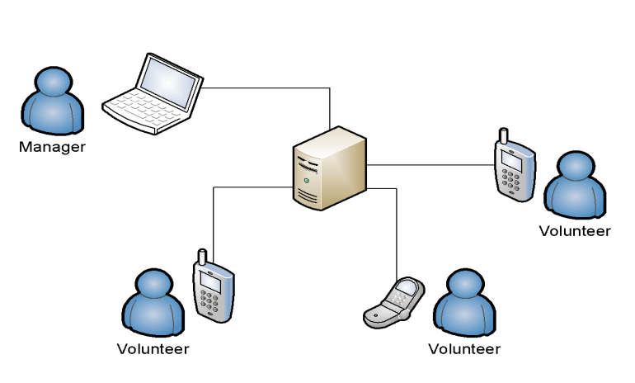
Figure 1: Functionality of VMS
At the time of a crisis, crisis manager initializes the system by defining the crisis using web portal. Then volunteers open the mobile application and wait for help requests. System detects the location and other individual information of all volunteers then according to the needs defined by manager for any incident, system automatically requests volunteers and accomplishes all the needs.

Features
Resource Management
Volunteers and their useful stuff which they can provide to the needy can be managed easily by the managers. This feature is semi-automatic. VMS intensively assists the crisis manager for resource management at the time of crisis by helping in selecting the volunteers according to region, type of the crisis etc. VMS assist Manager heavily based on the crisis nature and severity of the crisis.
Incident Management
Any number of incidents can be managed by system. System behaves differently to the different incidents. There can be different needs, different resource assignments and also different states like active or resolved. More than one incident can be raised in a crisis and each incident will have individual need list and requirements, these will be handled by VMS by assisting the crisis manger in handling them according to the nature of incidents.
Information Gathering
Volunteer can be used as an information source for new incidents and also for status of the existing incidents.
[ All features or some features must be summarized here. ]

Functional Requirements
[Some key requirements must be given here. I don’t know the format but table format of use cases is not good in my opinion. Total section must be around 10 pages.]

Non-Functional Requirements
Automatic Request Sending
Help requests in VMS are not message-like or sms-like information which are sent from one side to other side. Instead, they are saved data which are shown to volunteers based on automatic selections of volunteers.
Manager defines the needs of an incident and starts the “automatic request sending”. Then system automatically selects volunteers with the required qualifications and shows them the request. According to the answers, system may re-show the request to other volunteers. It is an ongoing process. A sample case for this requirement is given below:
An incident needs 3 people and a car. After manager defines the needs and starts the automatic request sending; system automatically selects and shows request to 3 people of which one has a car preferably.
The one who has the car replies as “Yes” after 2 minutes. The second one replies the request as “No” after 3 minutes. System automatically shows the request to another volunteer. The last one doesn’t reply the request within 10 minute. System automatically cancels the request and shows a new request to another volunteer.
Thus system automatically completes the need list.
[ It is fine if we find another nonfunctional requirement ]

System Architecture
[Architects should decide what information should be given here. We don’t have enough space. It should be around 1-1.5 page]

Summary
[0.5 page summary is required to conclude everything. I will write this.]

Revision History
Date | Name | Work | Version
2009/12/23 | Abdullah Arslan | Created the draft  Section 1, Section 2 | 1

